Deploy Netflix Clone on Kubernetes

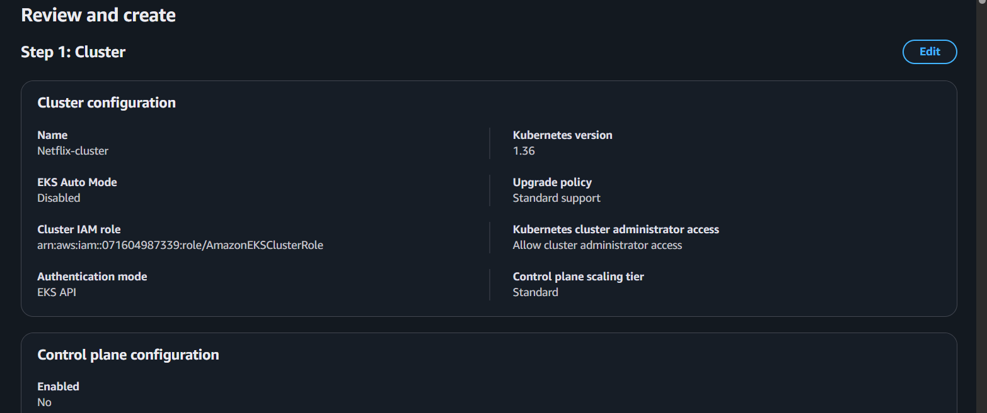

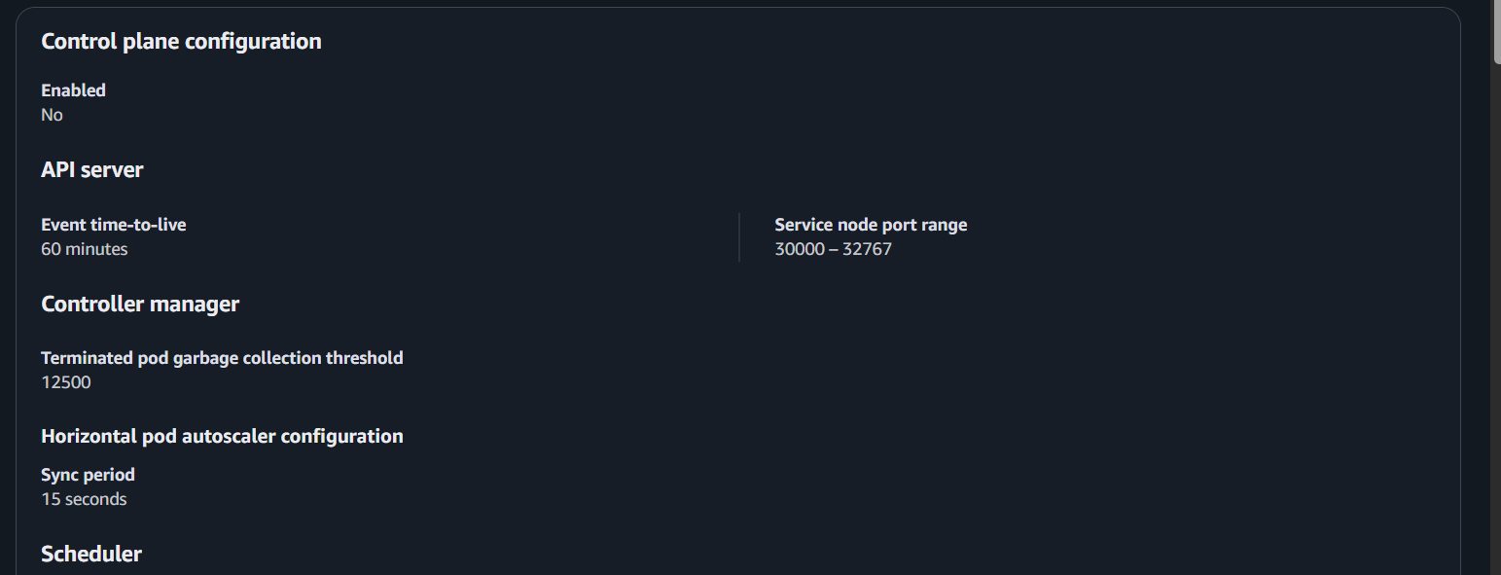

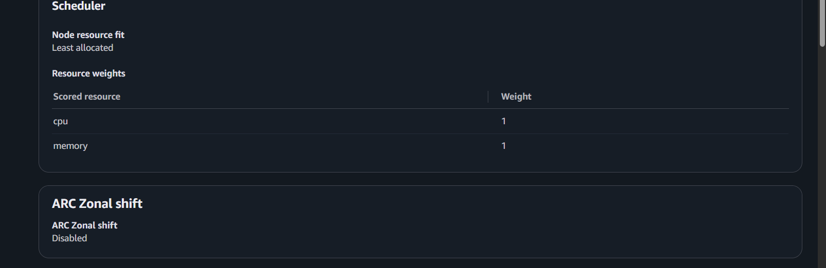

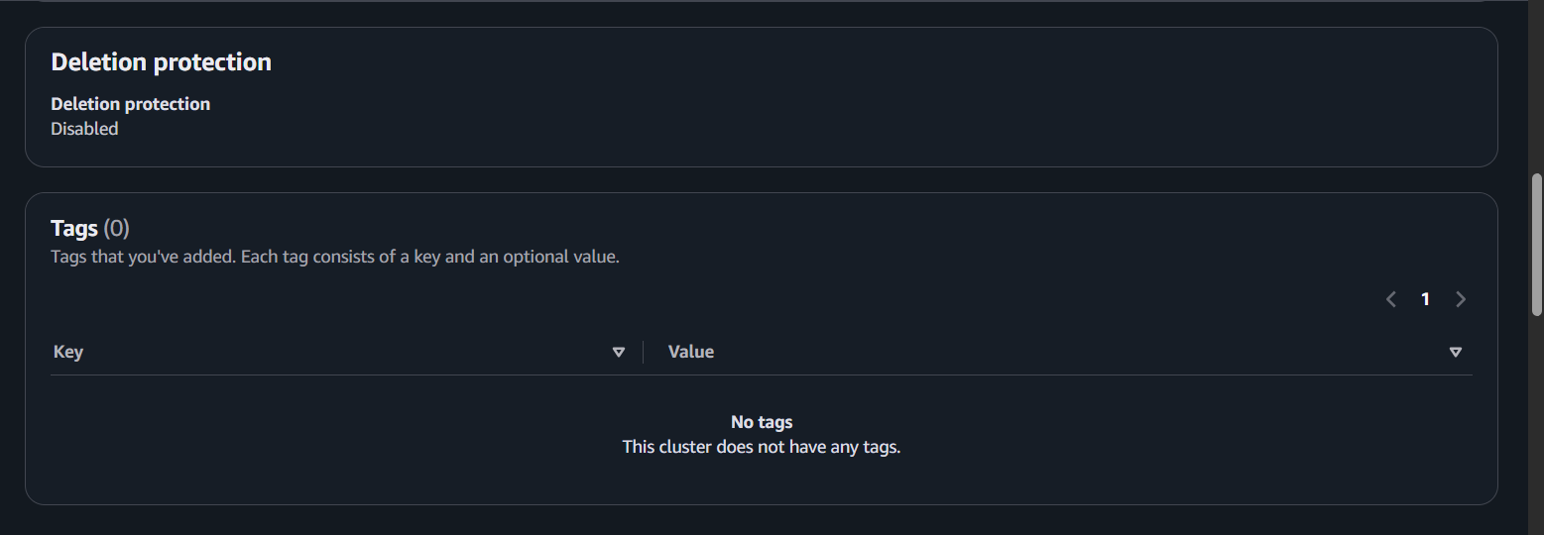

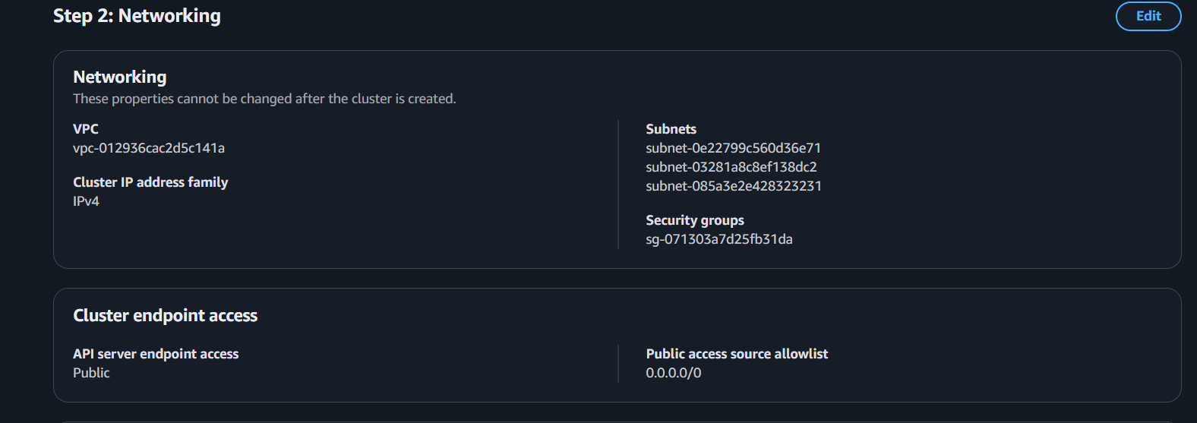

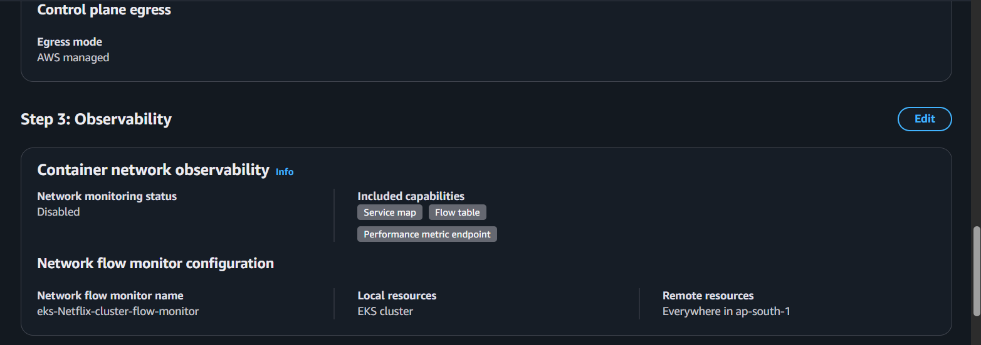

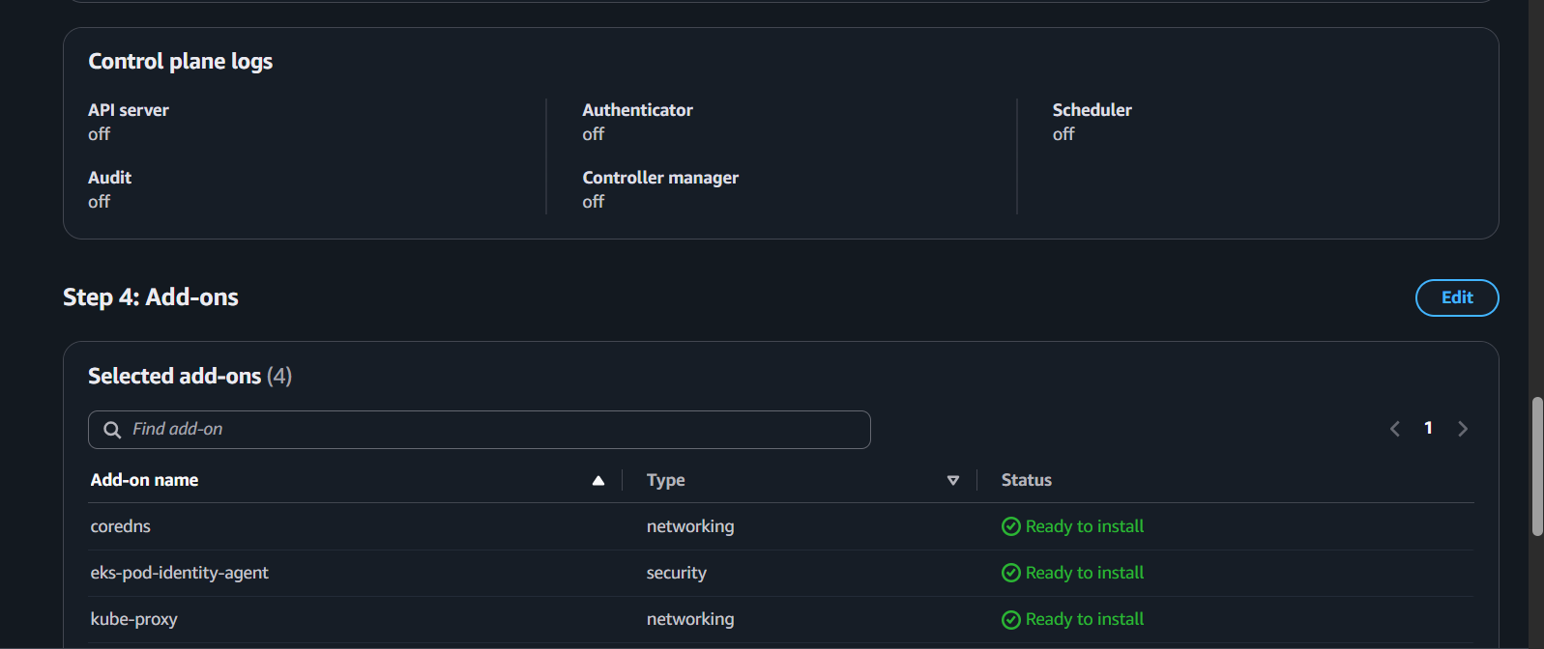

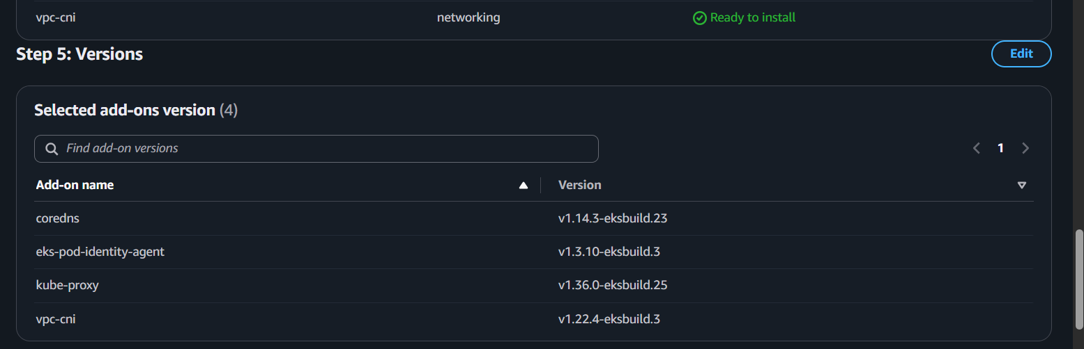

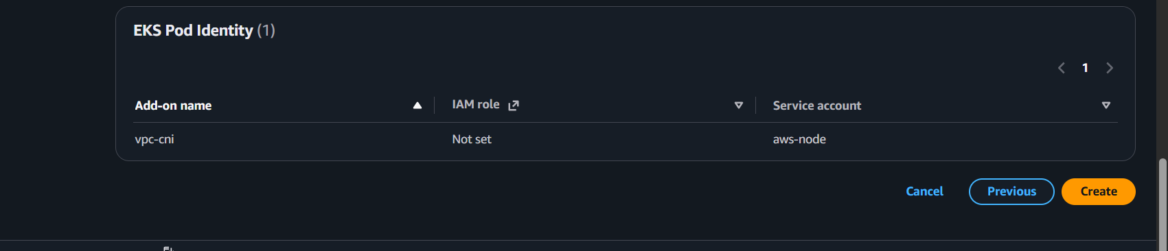

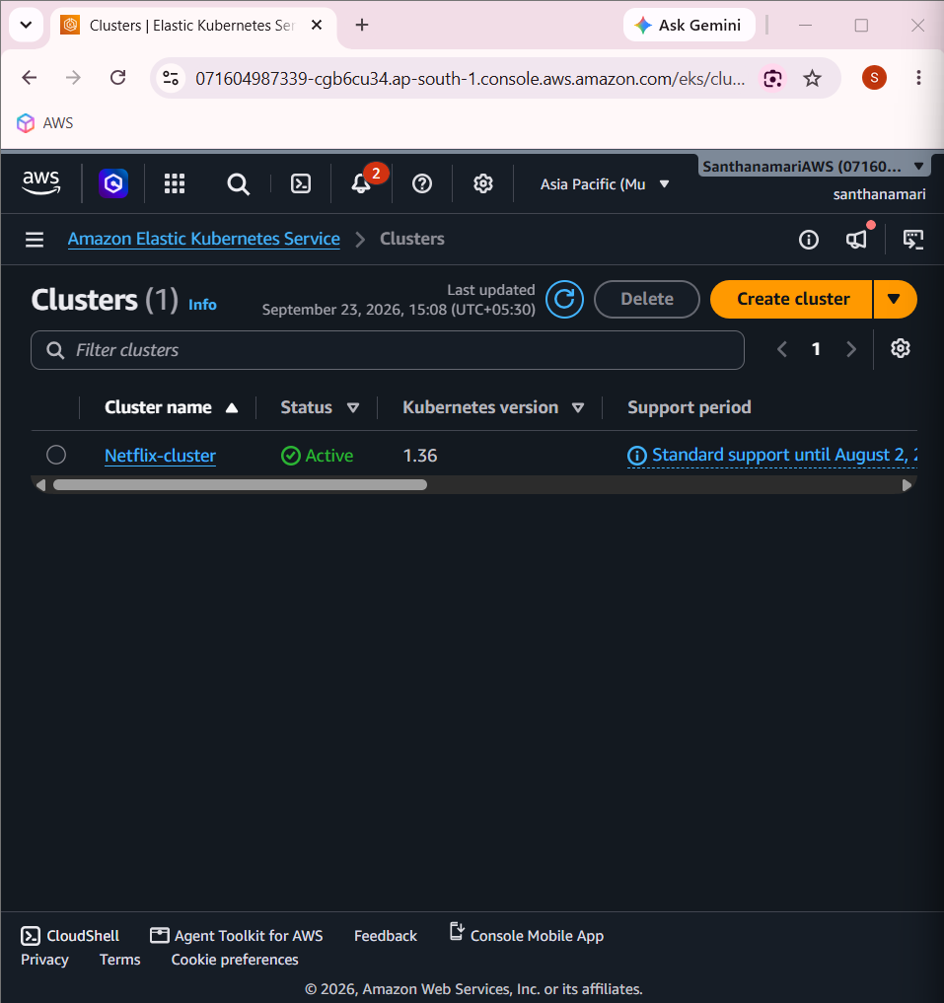

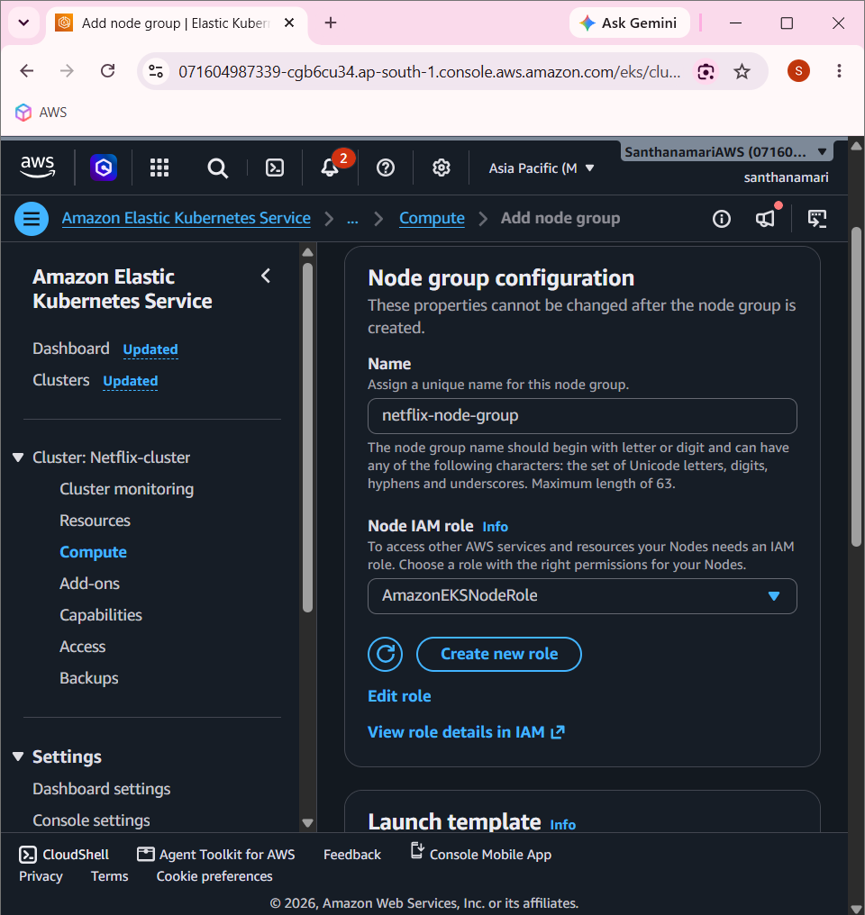

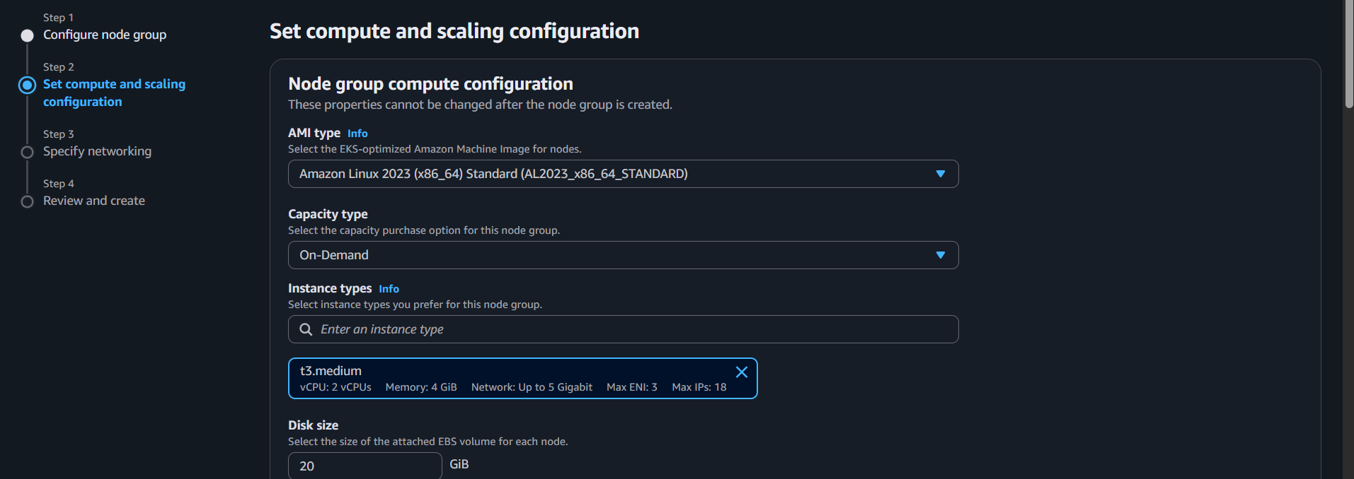

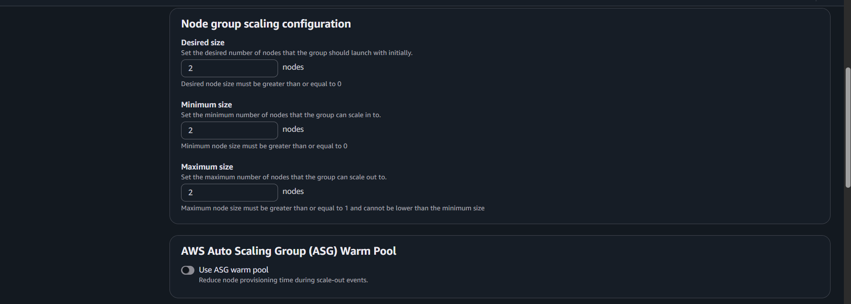

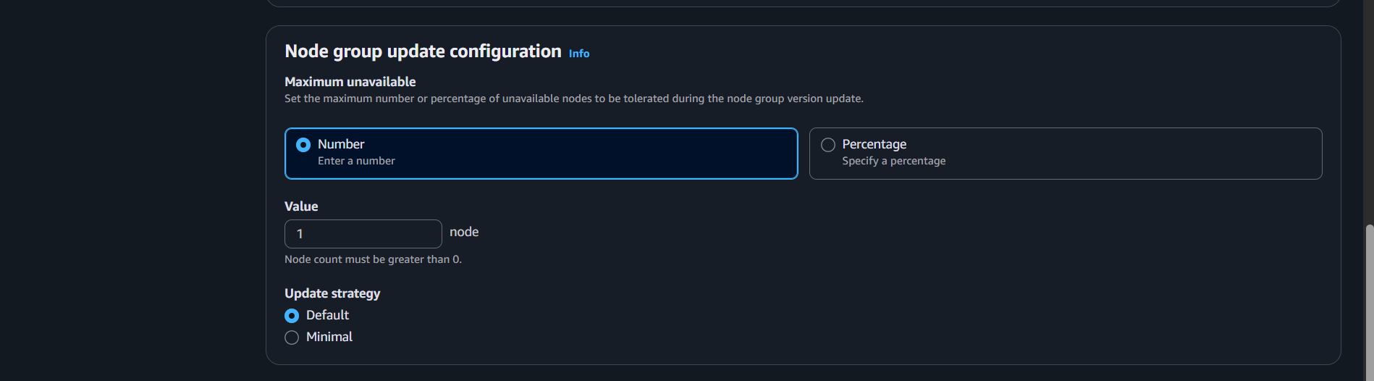

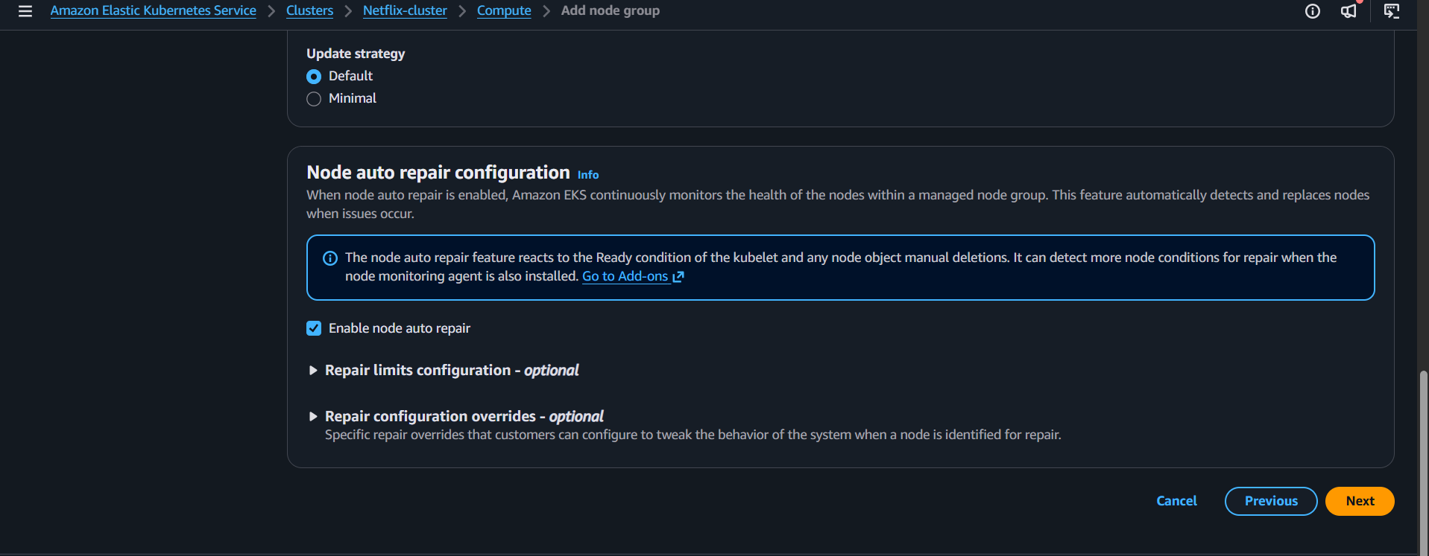

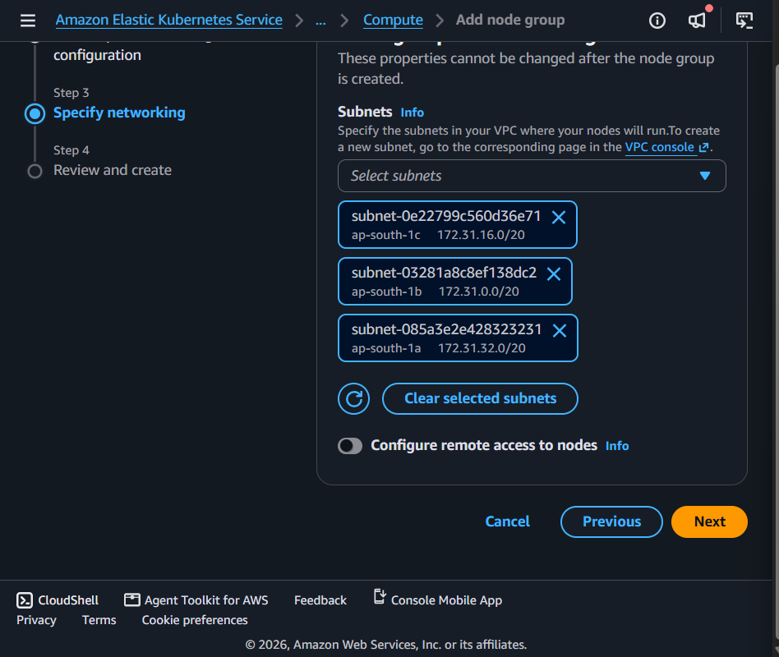

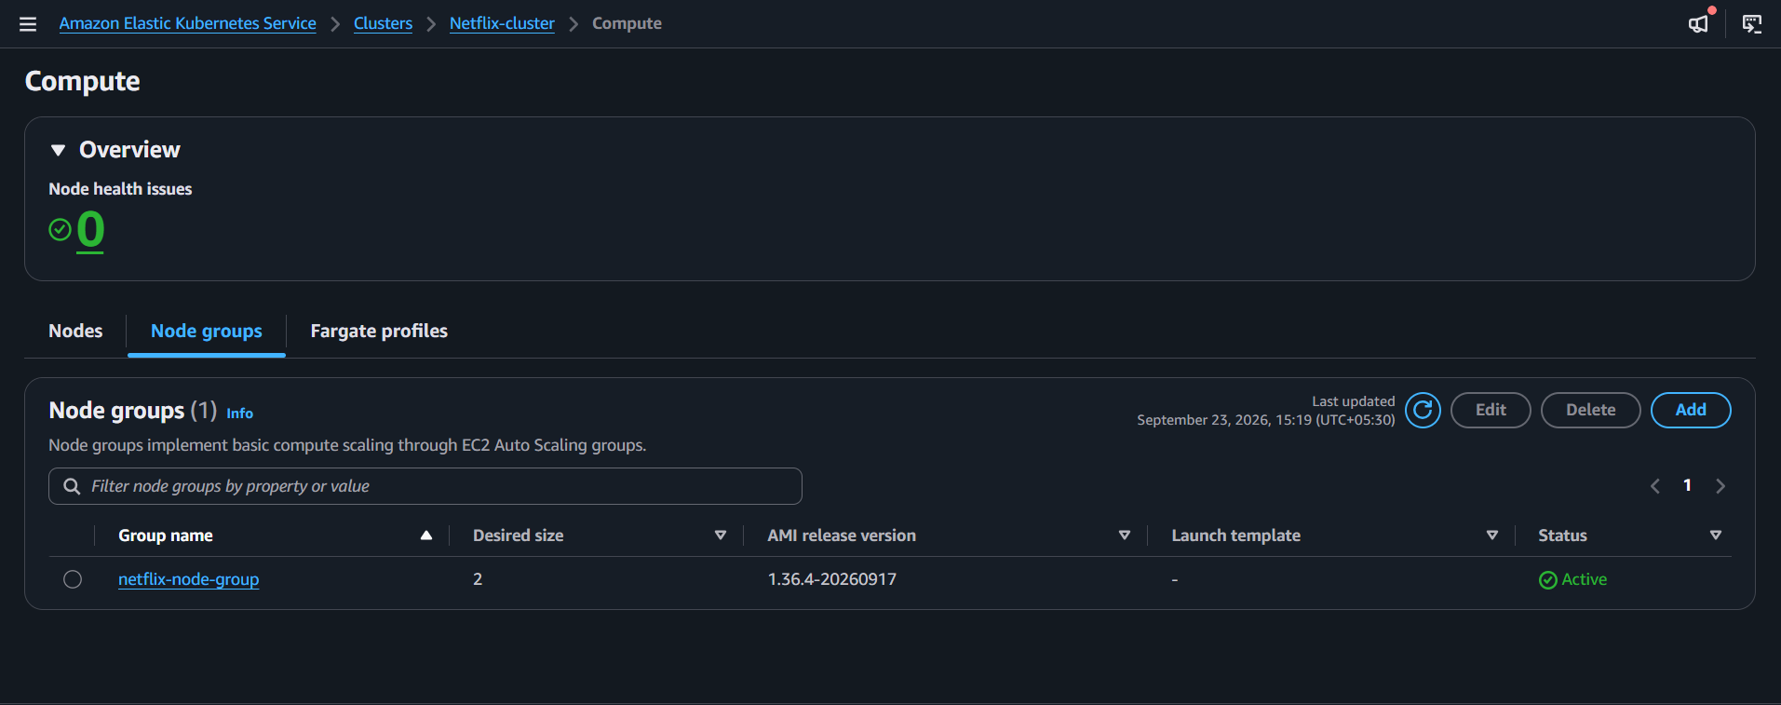

aws --version

kubectl version --client

aws eks list-clusters --region ap-south-1

aws eks update-kubeconfig --name Netflix-cluster --region ap-south-1

aws sts get-caller-identity

aws eks list-access-entries --cluster-name Netflix-cluster --region ap-south-1

aws eks create-access-entry --cluster-name Netflix-cluster --principal-arn arn:aws:iam::071604987339:user/swiggy-user --region ap-south-1

aws eks associate-access-policy --cluster-name Netflix-cluster --principal-arn arn:aws:iam::071604987339:user/swiggy-user --policy-arn arn:aws:eks::aws:cluster-access-policy/AmazonEKSClusterAdminPolicy --access-scope type=cluster --region ap-south-1

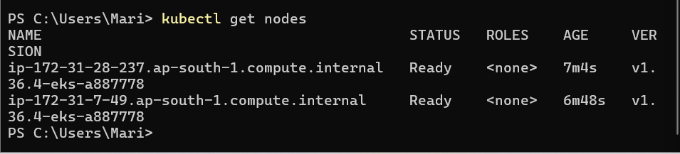

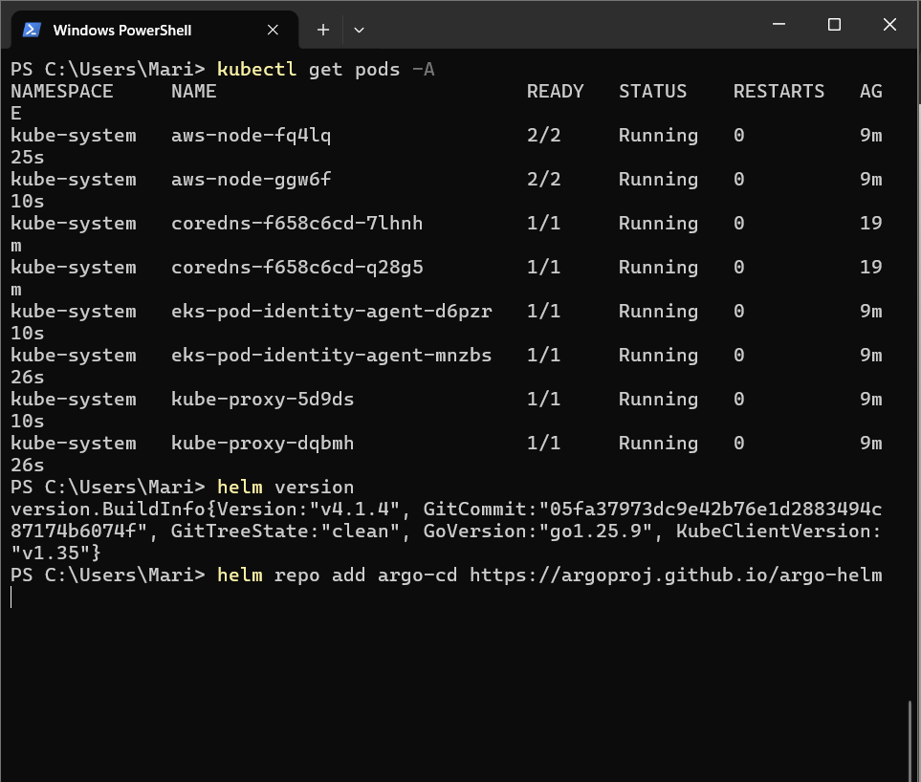

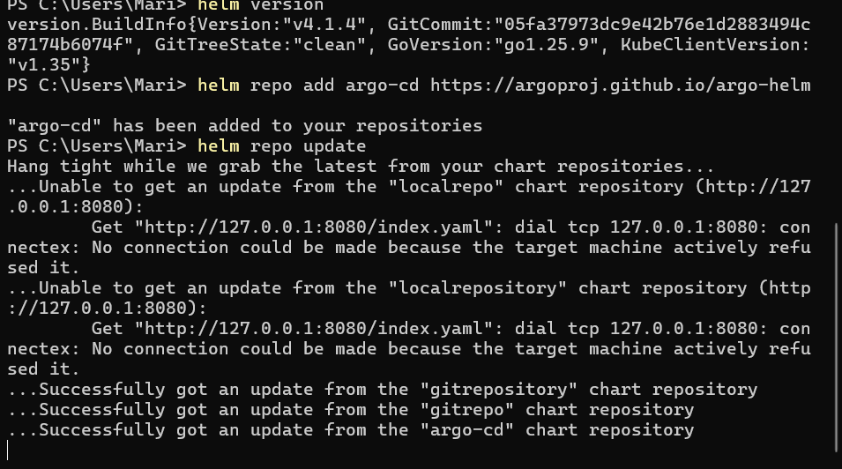

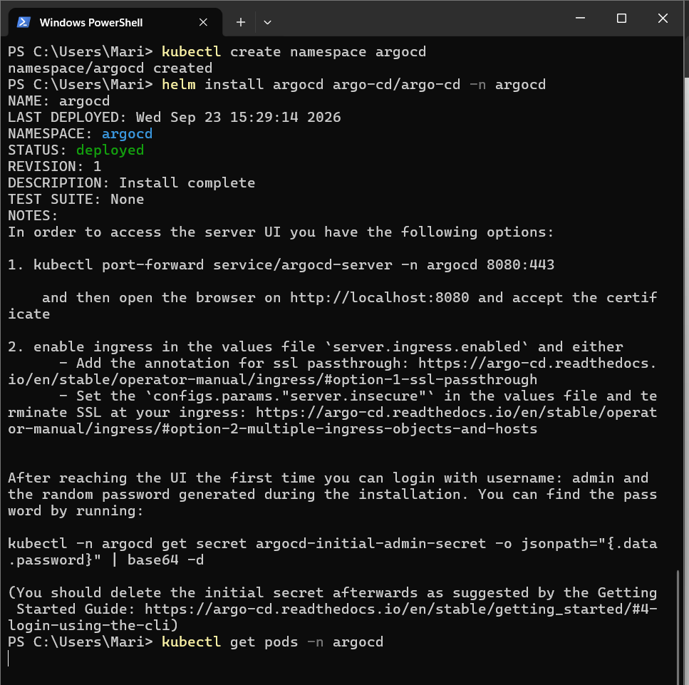

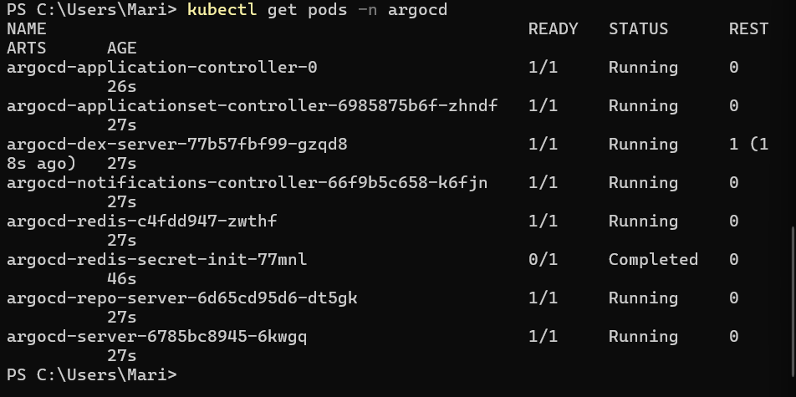

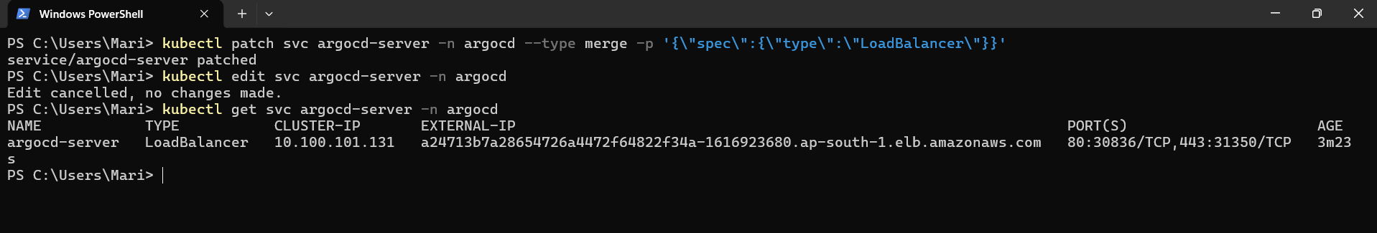

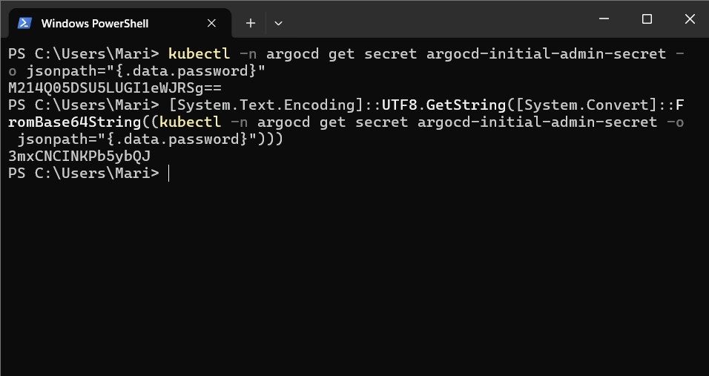

M214Q05DSU5LUGI1eWJRSg==
3mxCNCINKPb5ybQJ

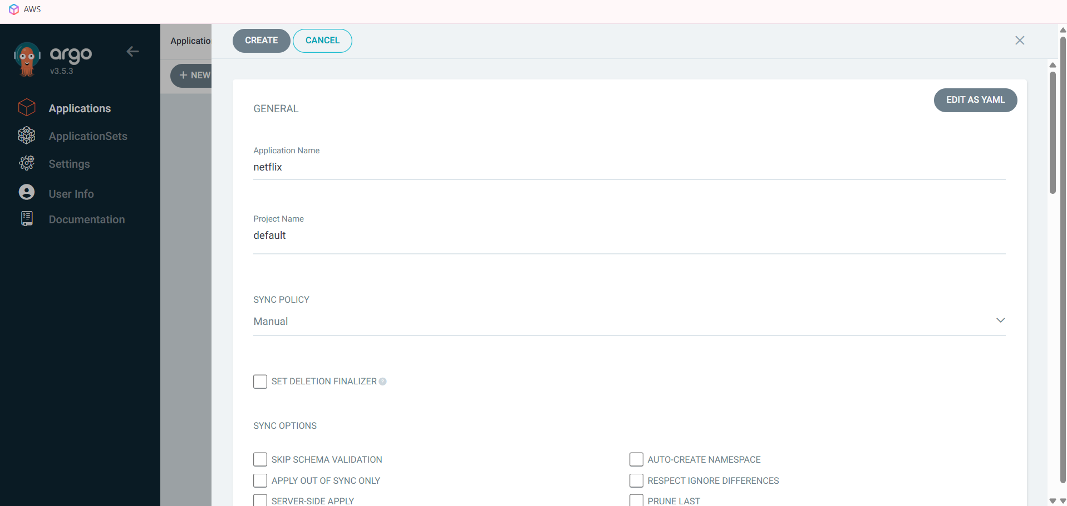

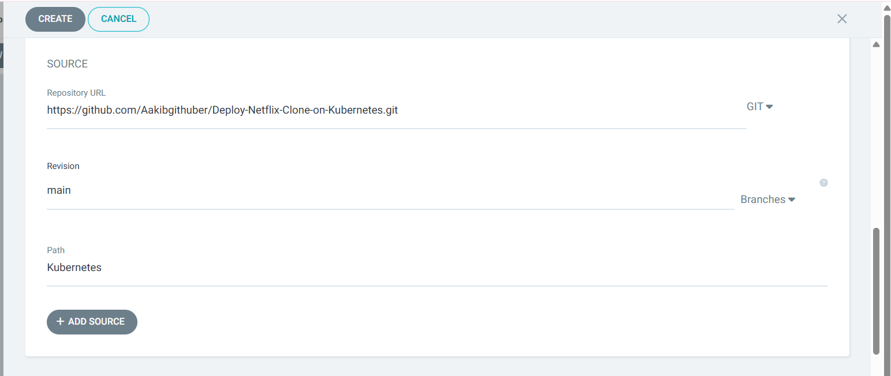

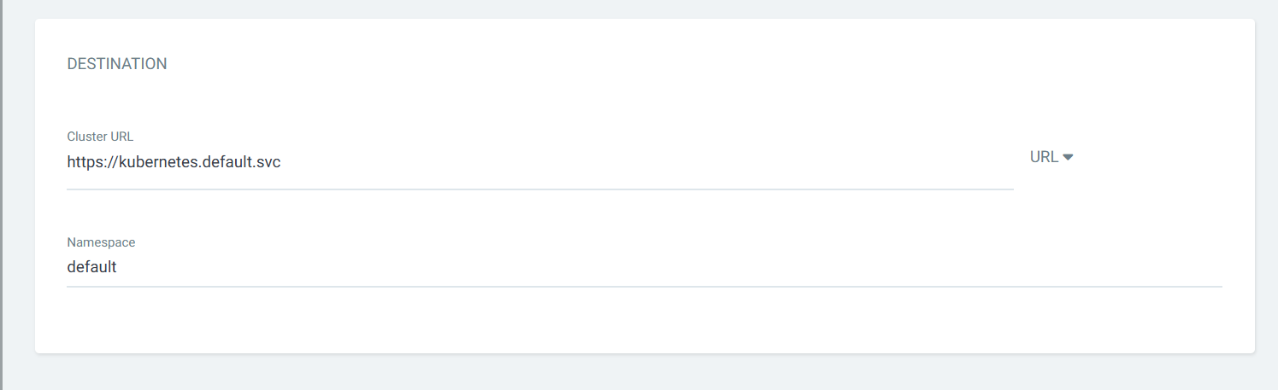

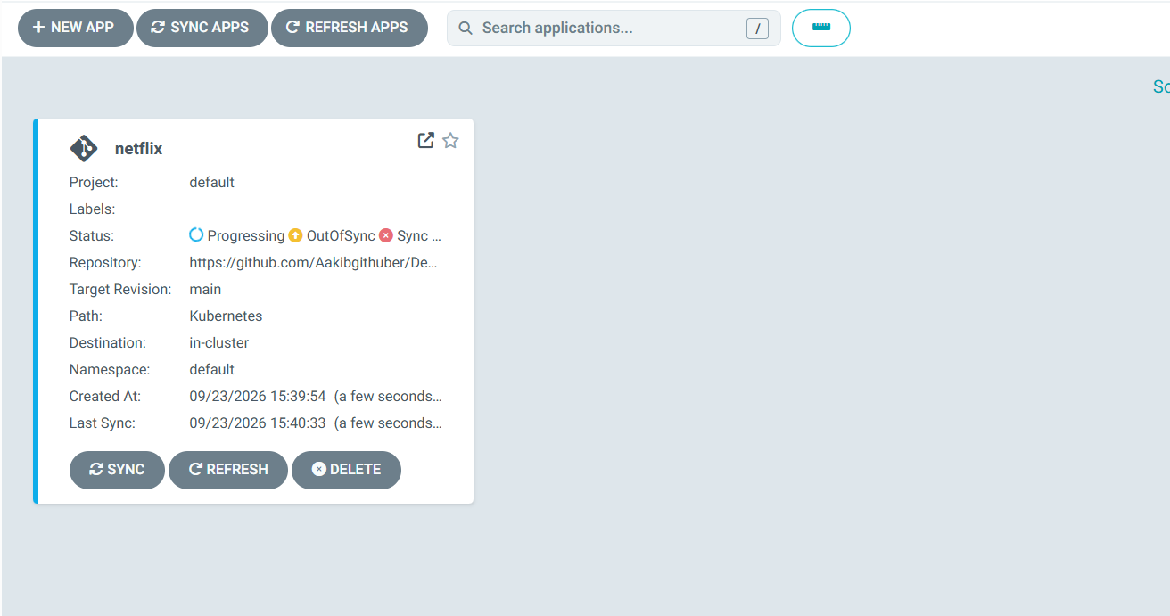

Click sync

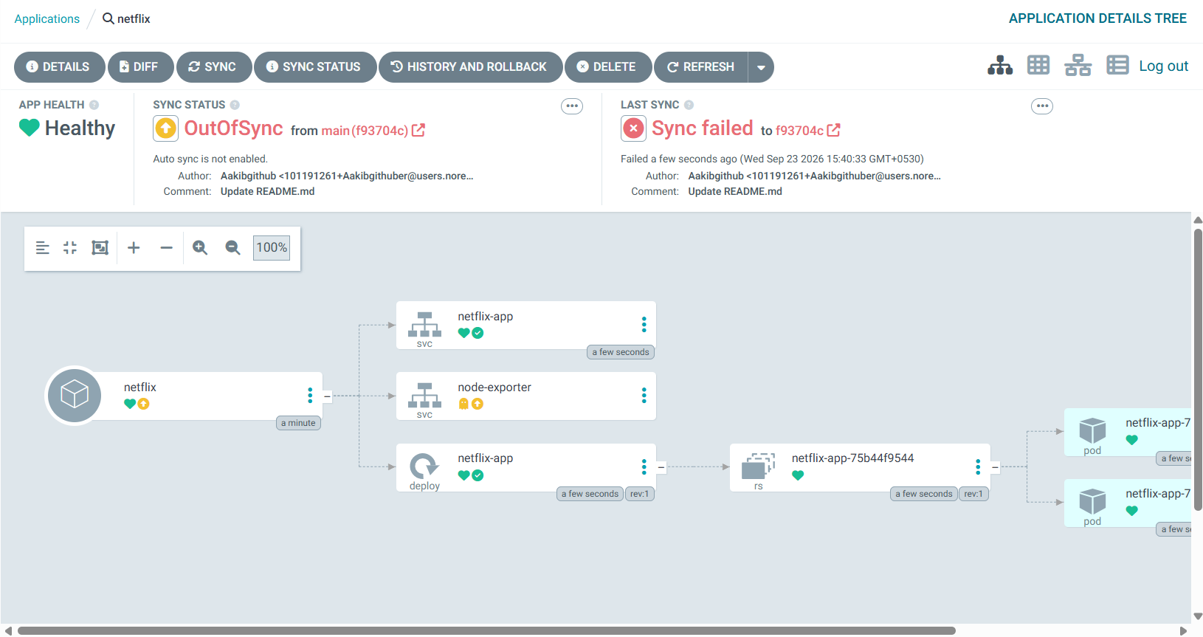

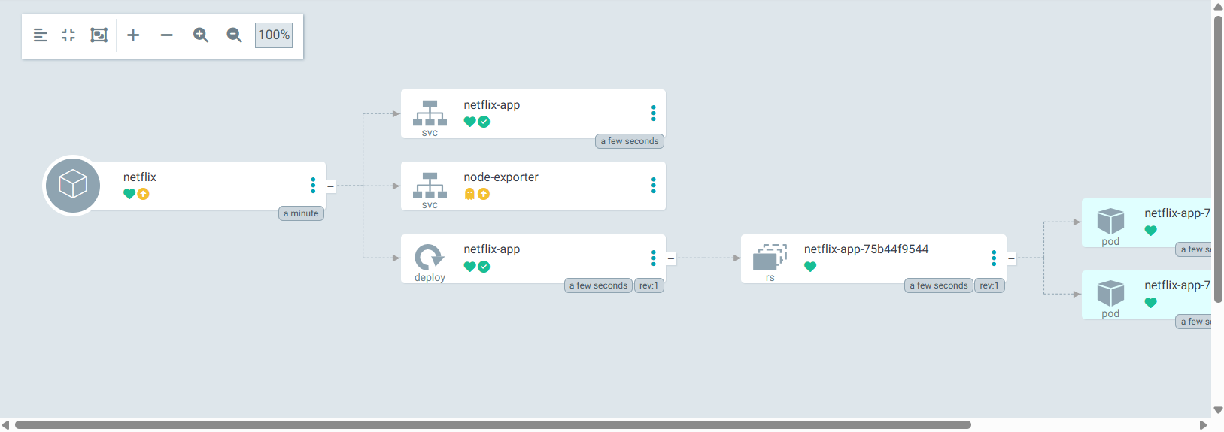

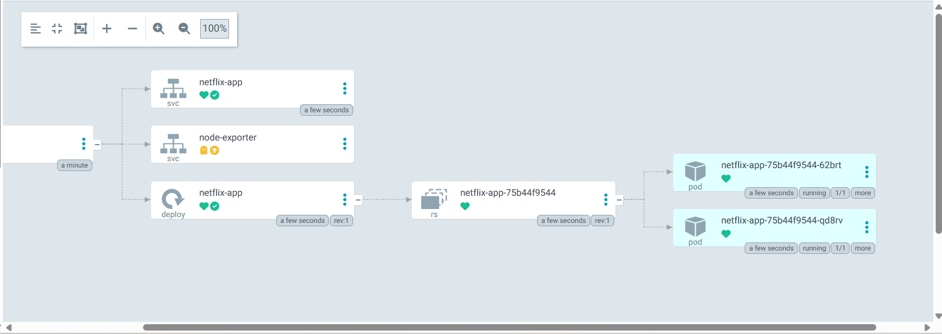

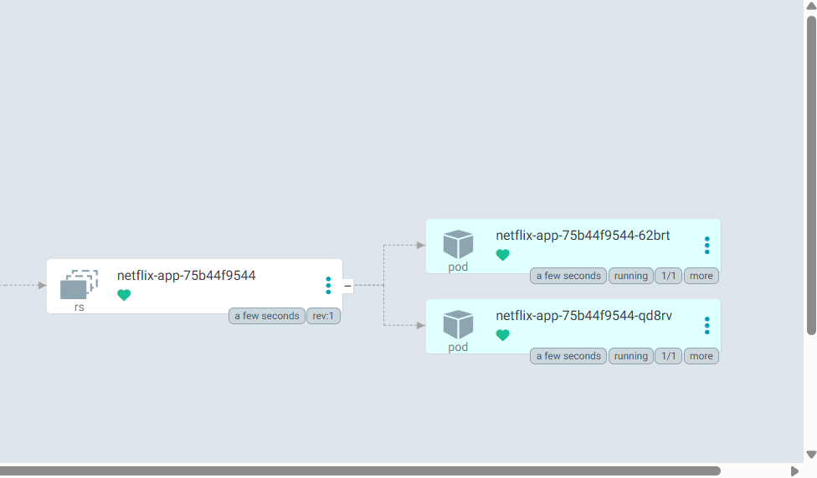

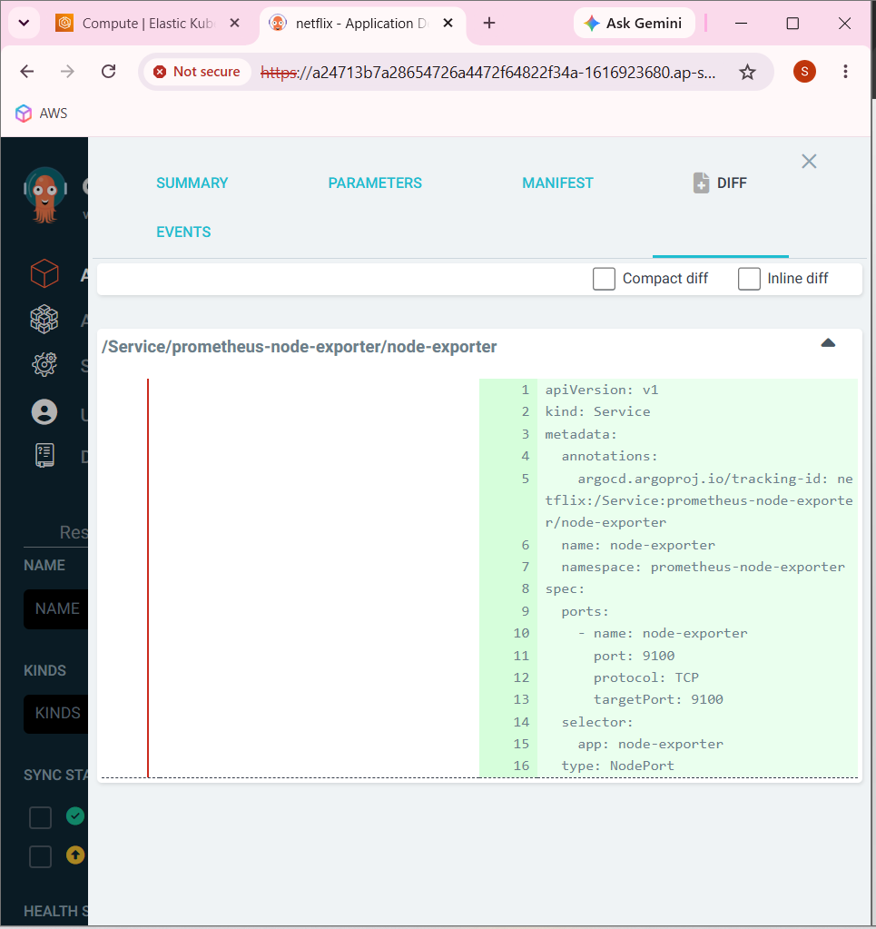

apiVersion: v1
kind: Service
metadata:
annotations:
argocd.argoproj.io/tracking-id: netflix:/Service:prometheus-node-exporter/node-exporter
name: node-exporter
namespace: prometheus-node-exporter
spec:
ports:
- name: node-exporter
port: 9100
protocol: TCP
targetPort: 9100
selector:
app: node-exporter
type: NodePort
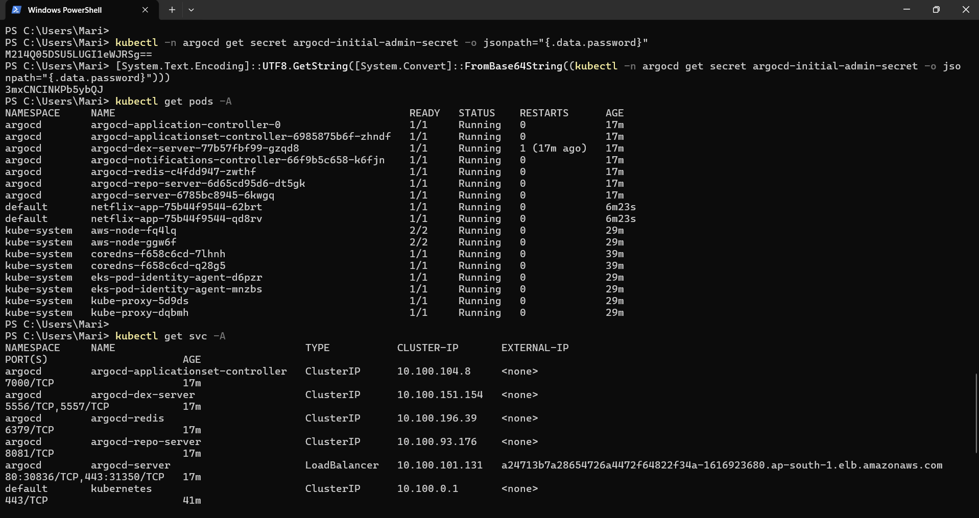

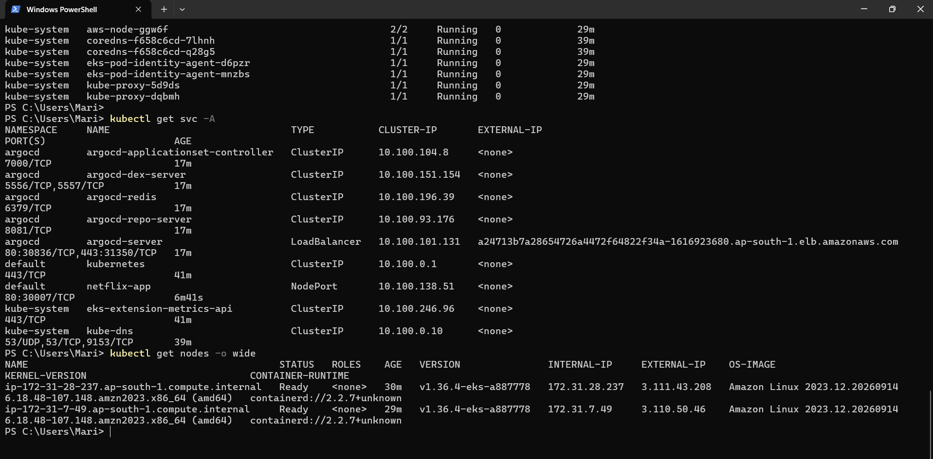
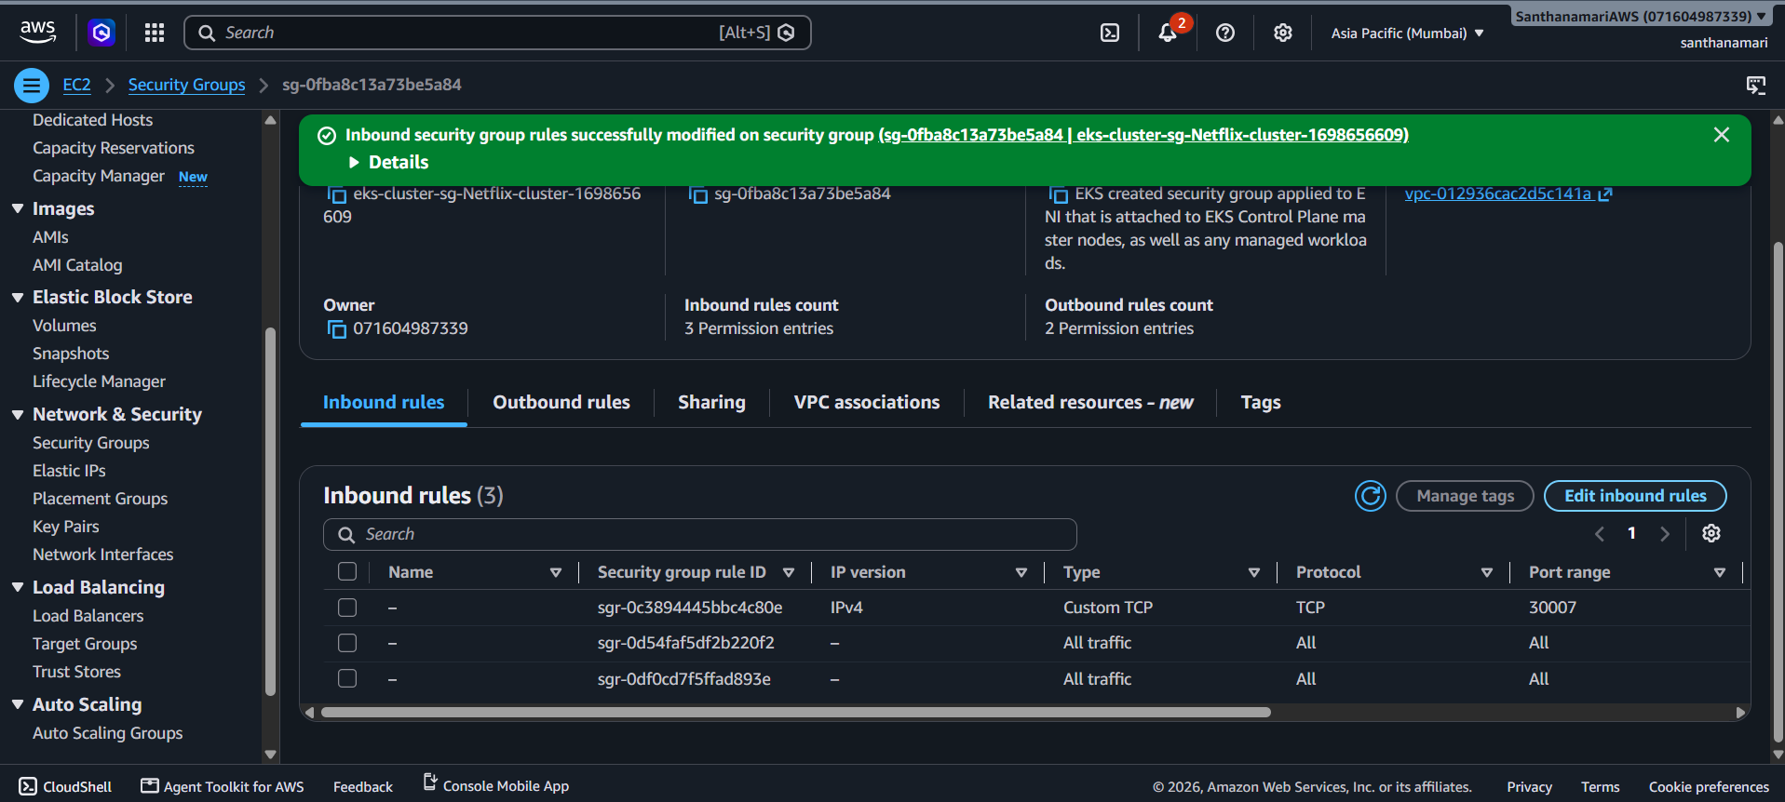

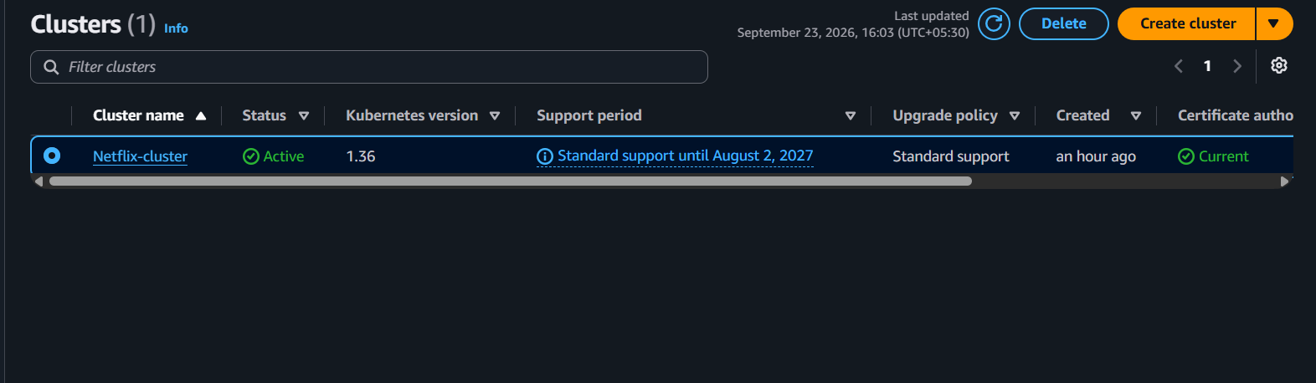
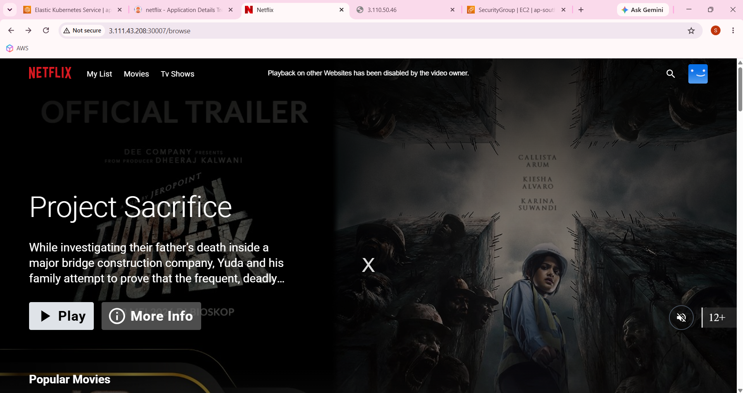

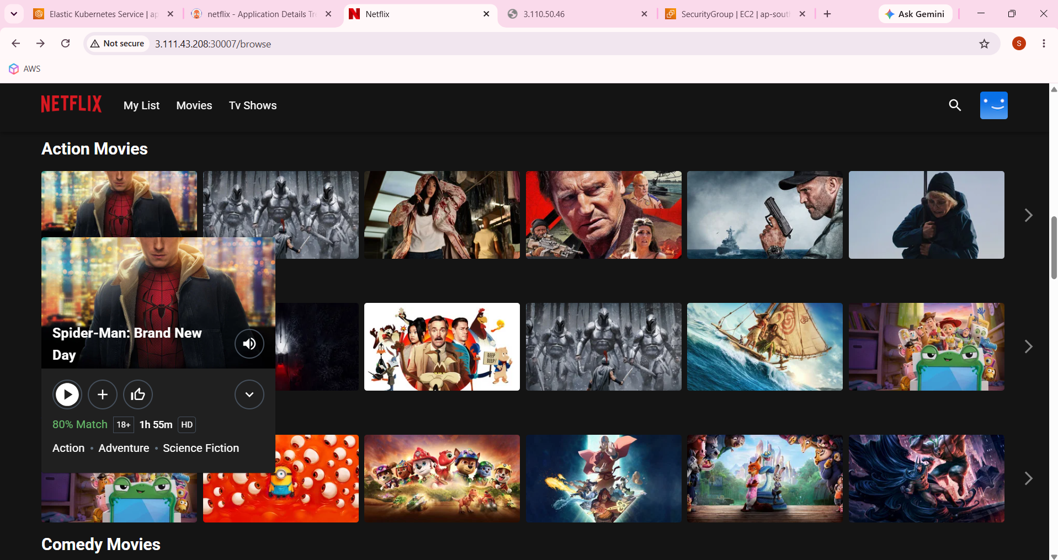
http://3.111.43.208:30007/browse

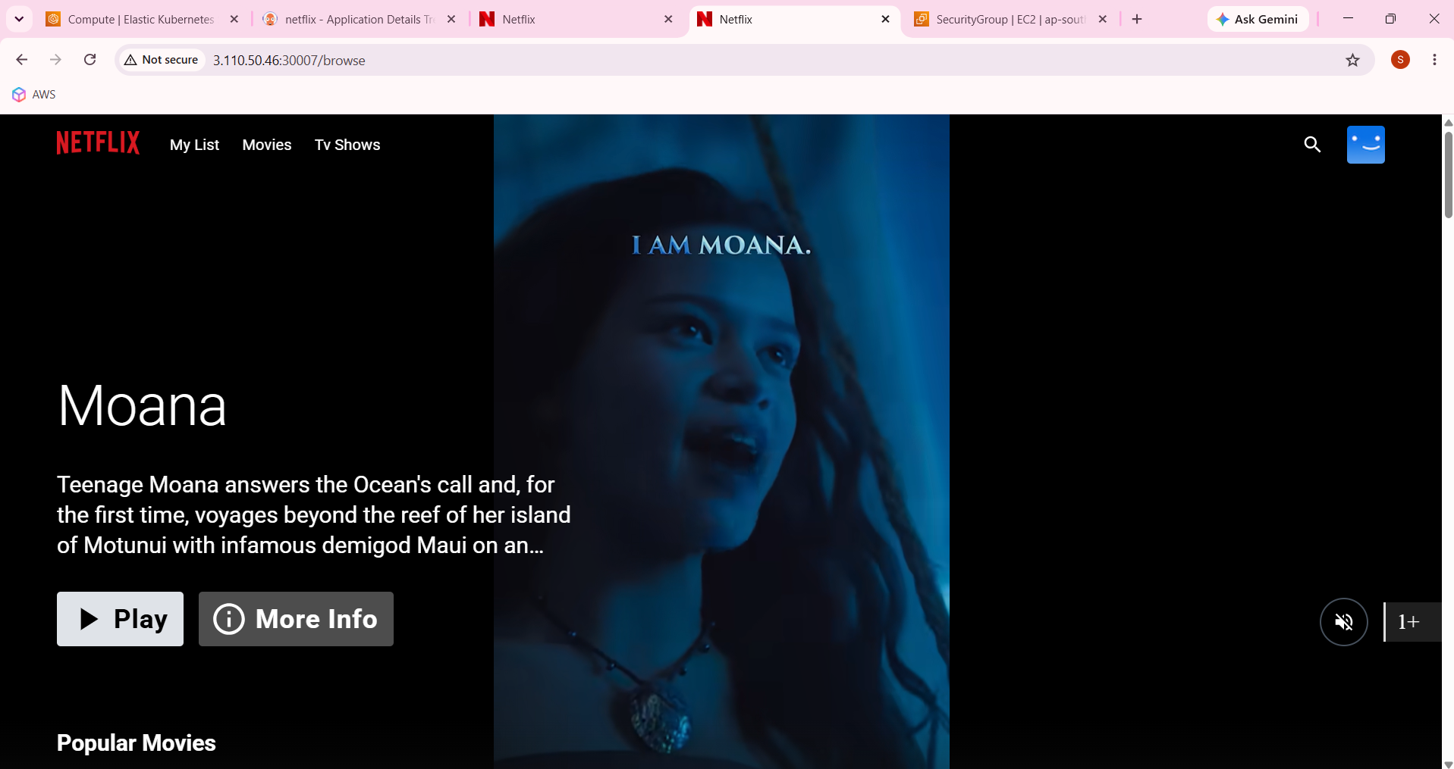

http://3.110.50.46:30007/browse

____________________________________________________________________________

